Database System Engineering and Distributed Backend Development
Course Code: 25CS13002E
ROLL NO:2520030177
NAME: P.HARINI
SQL PRACTICE NOTES - ORDERS TABLE
Query 1: Create Data Base
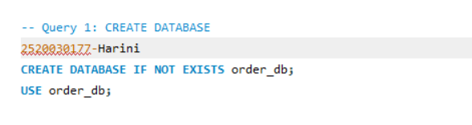
Output:
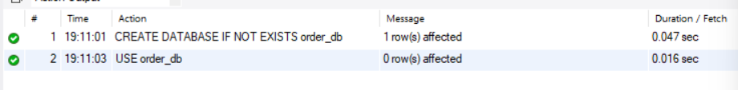

Query 2: CREATE TABLE
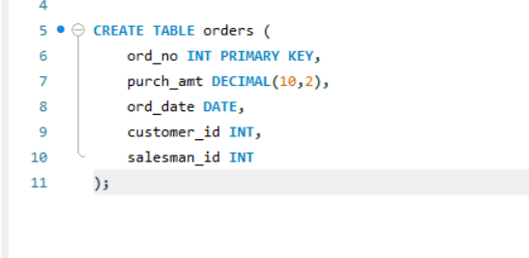
Output:

Query 3: INSERT DATA
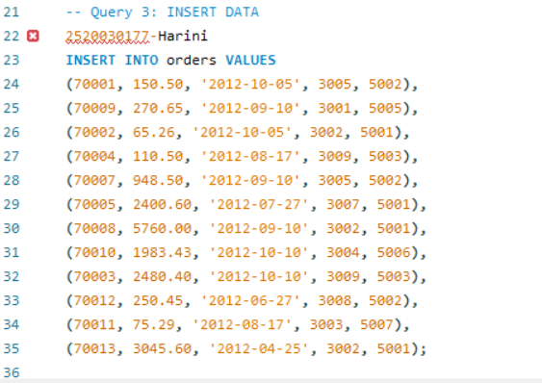
Output:

Query 4: WHERE CLAUSE
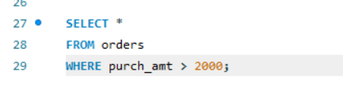
Output:
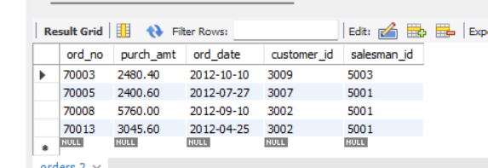

Query 5:WHERE CLAUSE
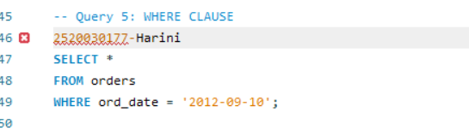
Output:
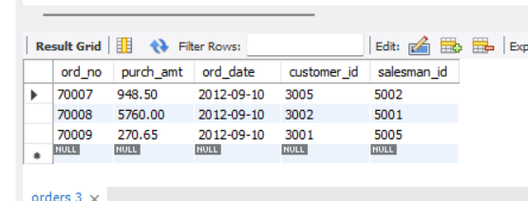

Query 6: WHERE CLAUSE
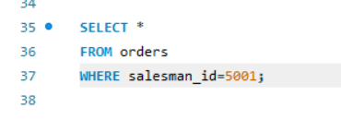
Output:
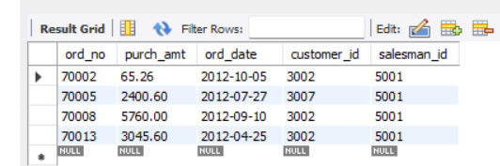

Query 7: ORDER BY
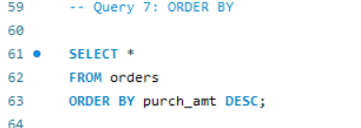
Output:
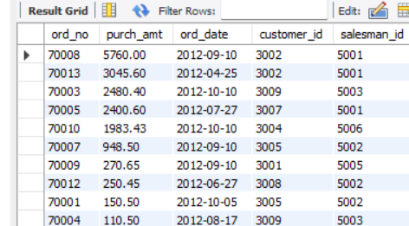
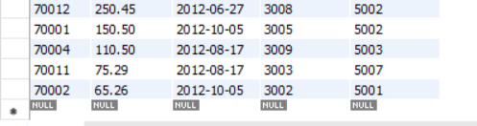

Query 8: ORDER BY
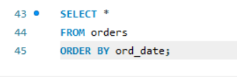
Output:
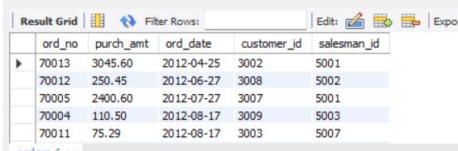
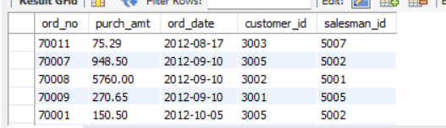
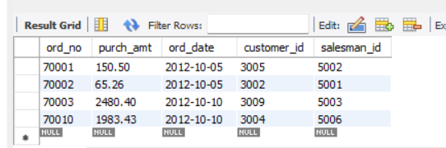

Query 9: SUM()
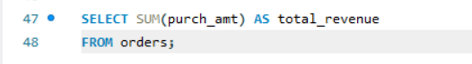
Output:
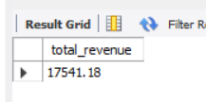

Query 10: AVG()
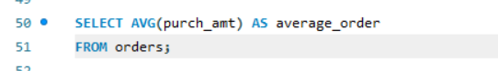

Output:
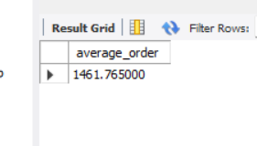

Query 11: MAX()

Output:
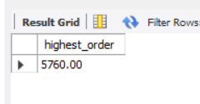

Query 12: MIN()
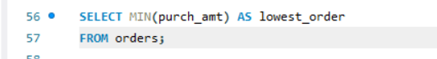
Output:
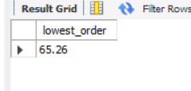

Query 13: COUNT()
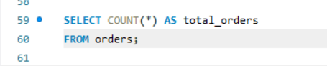
Output:
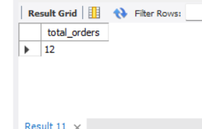

Query 14: GROUP BY
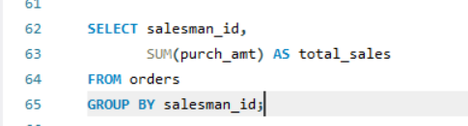
Output:
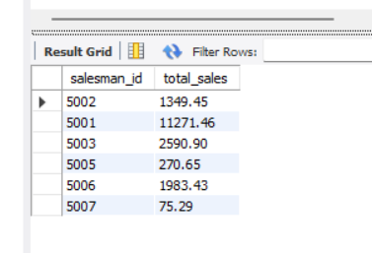
Query 15: GROUP BY
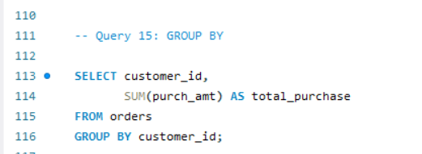
Output:
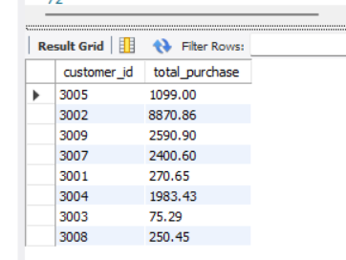

Query 16: GROUP BY + MAX()
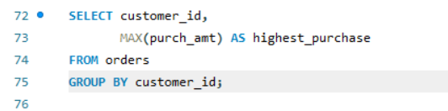
Output:
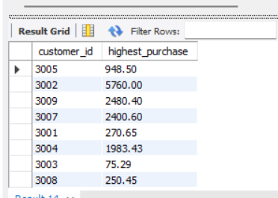

Query 17: GROUP BY + HAVING
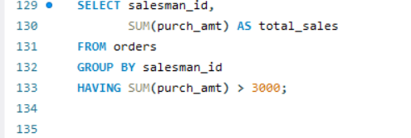
Output:
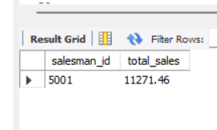

Query 18: GROUP BY + HAVING
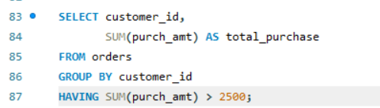
Output:
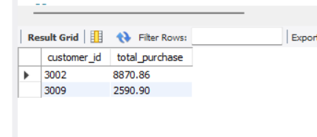
Query 19: GROUP BY + HAVING
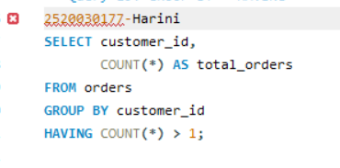
Output:
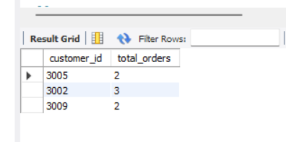

Query 20: GROUP BY + HAVING + ORDER BY
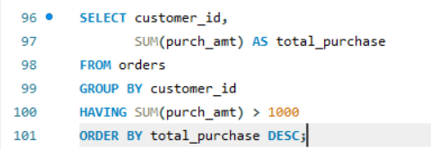
Output:
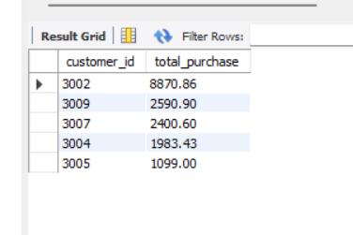

Query 21: BETWEEN + HAVING
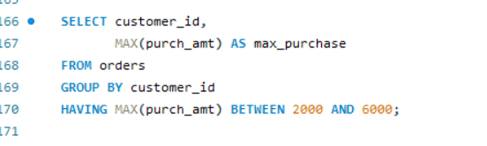
Output:
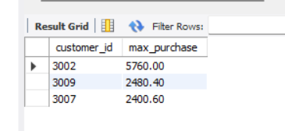

Query 22: COUNT + HAVING
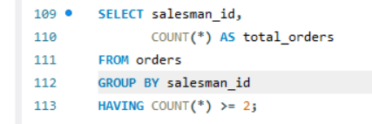
Output:
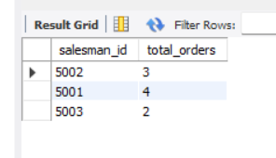
Query 23: MAX + GROUP BY + HAVING
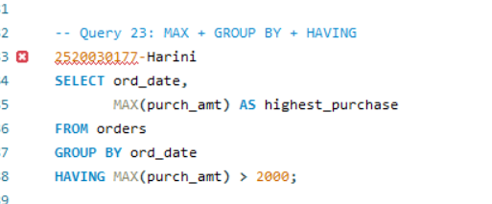
Output:
